**DAILY ONLINE ACTIVITIES SUMMARY**

|  |  |  |  |  |  |  |  |  |
| --- | --- | --- | --- | --- | --- | --- | --- | --- |
| **Date:** | 22/05/2020 | | | | | **Name:** | RIYA C.P | |
| **Sem & Sec** | IV B | | | | | **USN:** | 4AL18CS070 | |
| **Online Test Summary** | | | | | | | | |
| **Subject** | | Operating Systems | | | | | | |
| **Max. Marks** | | 30 | | **Score** | | | 14 | |
| **Certification Course Summary** | | | | | | | | |
| **Course** | Introduction to Digital Marketing | | | | | | | |
| **Certificate Provider** | | | Greatlearning academy | | **Duration** | | | 2.5 hours |
| **Coding Challenges** | | | | | | | | |
| **Problem Statement1:** Write a C or Java program to implement round robin type of process scheduling. Input: Process with burst time, arrival time and specify the time quantum Output: Processes scheduled based on the round robin type of scheduling, with its average waiting time.  **Problem Statement2:** Write a C Program to implement various operations on Singly Linked List Stack. | | | | | | | | |
| **Status:** Executed | | | | | | | | |
| **Uploaded the report in Github** | | | | | YES | | | |
| **If yes Repository name** | | | | | lockdown-coding | | | |
| **Uploaded the report in slack** | | | | | YES | | | |

**Online Test Summary**: 18CS43 test was scheduled from 9:15 am t0 9:55am .The portion for the IA was 1st module there were 30 questions and the time assigned was 30 minutes the questions were mcq type.

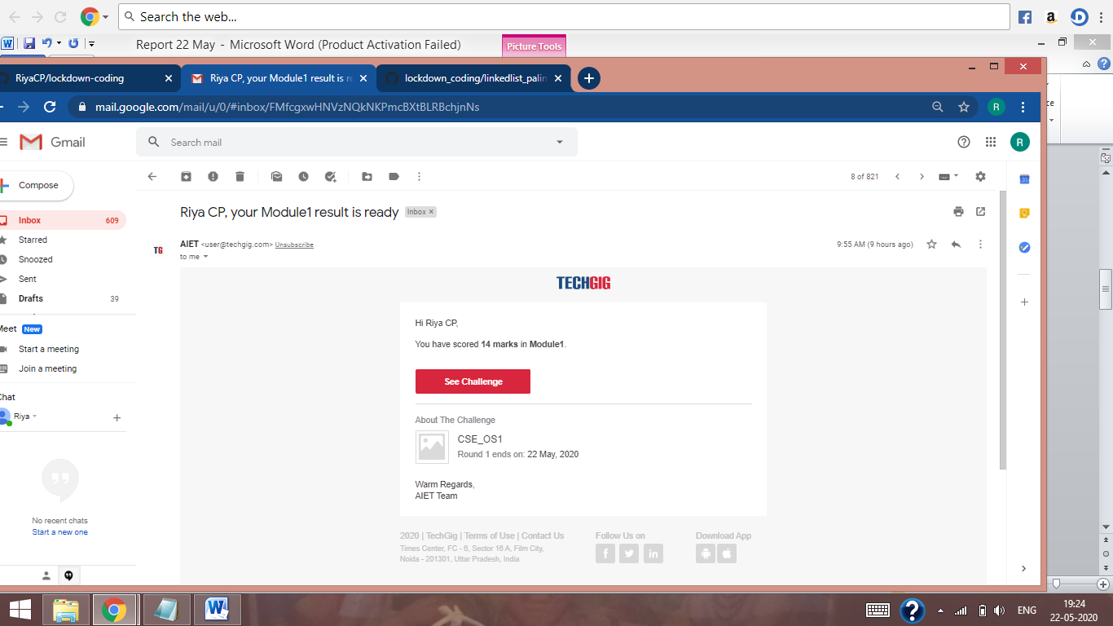

The above snap shot is the completion of the test and the marks allotted.

**Online Certification Course Summary**: Today I had registered for the new course that is Introduction to Digital Marketing,The Instructor is Anirban Chaudhuri. Today I learnt about how consumers come to know about a particular product and how they rate it weather it can be used further or not like the quality of the product etc. And I also learnt about New Medias how it is going to be Owned, Shared, Earned and Paid and also about some of the famous brands like NYKKA what is the purpose of that brand and how it actually attracts the customers.

Introduction to Facebook Marketing was another field which was interesting and I also came to know about what is the purpose of using Facebook as a Marketing Channel.

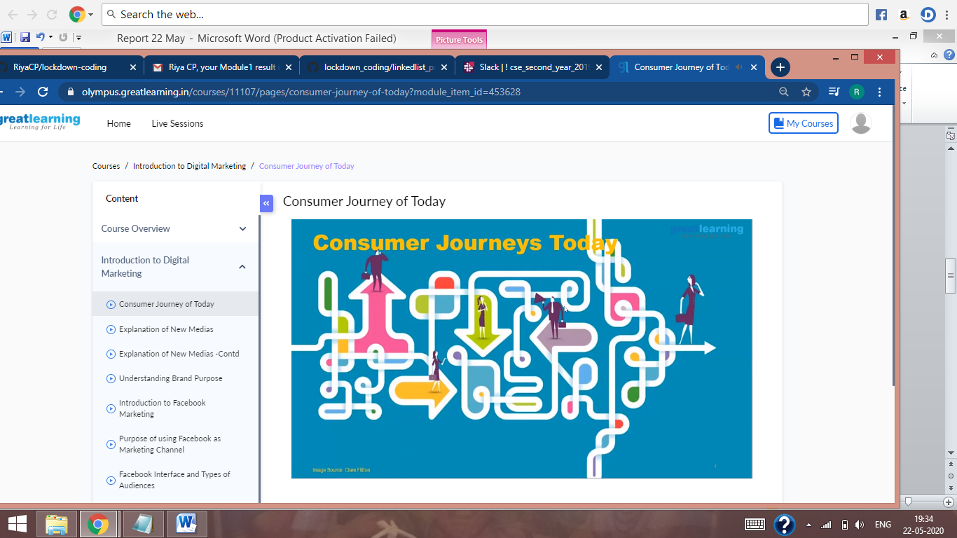

The above mentioned is the snap shot of Today’s Session.

**Online Coding Summary**:Today I had received one program prof.Harshitha CSE Dept and another from prof.Venkatesh CSE Dept. The programs is mentioned above in the coding challenges (pg.01). I have also uploaded it to my Github repository.

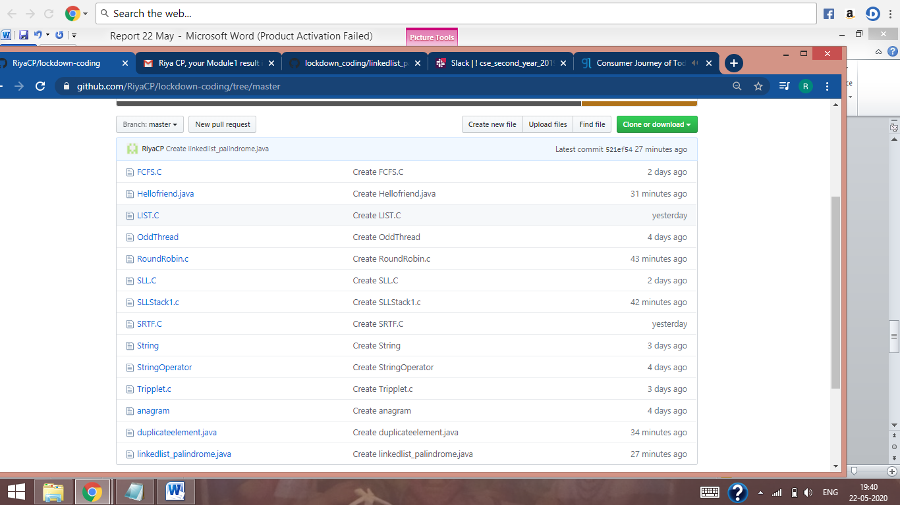

It is the snap shot of my repository were I have uploaded the code. File name is RoundRobin.c and SLLStack1.c